**RESTful API FOR A BLOGGING PLATFORM A NAAN MUDHALVAN REPORT**

***SUBMITTED BY***

**SUJITHA A 912421106016**

**SWATHI B 912421106017**

**BACHELOR OF ENGINEERING IN**

**ELECTRONICS AND COMMUNICATION ENGINEERING**



**SHANMUGANATHAN ENGINEERING COLLEGE ARASAMPATTI, PUDUKKOTTAI – 622 507**

**YEAR & SEMESTER : IV & VII SUBJECT CODE :NM1050**

**COURSE NAME :SaaS (SOFTWARE AS A SERVICE)**



**ANNA UNIVERSITY::CHENNAI 600 025**

**NOV/DEC 2024**

**BONAFIDE CERTIFICATE**

Certified that this Naan Mudhalvan report of **“RESTful API FOR A BLOGGING PLATFORM”** is the bonafide work of **“ SUJITHA A (912421106016)” & “SWATHI B (912421106017)”** who carried out the project work

under my guidance.

## SIGNATURE SIGNATURE

**Mrs. D. LATHA M.E., Dr. A.MUTHU MANICKAM M.E., Ph.D., NAAN MUDHALVAN COORDINATOR HEAD OF THE DEPARTMENT ASSISTANT PROFESSOR, ASSISTANT PROFESSOR,**

Department of Electronics & Department of Electronics &

Communication Engineering, Communication Engineering, Shanmuganathan Engineering College, Shanmuganathan Engineering College, Arasampatti – 622 507 Arasampatti – 622 507

Submitted for the Internship viva-voice on

INTERNAL EXAMINER EXTERNAL EXAMINER

**ACKNOWLEDGMENT**

At this pleasing moment having successfully completed our internship report, we wish to convey our sincere thanks to our beloved chairperson **Mrs. PICHAPPA VALLIAMMAL**, correspondent **Dr. P. MANIKANDAN B.E,** director(Academic) Shri **M.SHANMUGANATHAN**, director(Administration) Shri **M. PICHAPPA** and honourable secretary **Mr. M. VISWANATHAN** for their extensive support.

I thankful to our principal **Dr. KL. MUTHURAMU M.E(W.R)., M.E(S.E)., Ph.D., FIE., M.I.S.T.E**., Shanmuganathan engineering college, for providing the opportunity to conduct our project.

I extend our gratitude to **Dr. A.MUTHU MANICKAM M.E., Ph.D**., the head of the department and our internship co-ordinator of Electronics and communication engineering for providing a valuable suggestion and supports given through the study.

Gratitude never fails. We are grateful to our dynamic and effective internal guide **Asst. Prof. Mrs. D. LATHA, AP/ECE, M.E.,** for his valuable innovative suggestion, constructive interactions, constant encouragement and valuable helps that have been provided us throughout the project.

I also express my heartfelt thanks to all other staff members of Electronics communication engineering Department for their support. Above all, we thank our parents, for affording us the valuable education till now.

# ABSTRACT

This project aims to develop a RESTful API for an efficient, scalable inventory management system that allows seamless tracking and management of inventory items. The REST API, built to follow REST principles, provides robust support for CRUD (Create, Read, Update, Delete) operations on inventory records, empowering users to maintain an up-to-date database of items and related information. By utilizing MongoDB, a NoSQL database, this project enables flexible, high-speed data management suitable for handling extensive and diverse data formats, accommodating the scalability needs of modern applications. The API endpoints allow data access and modification through a structured and consistent approach, reducing potential errors and maintaining data integrity across various operations. On the backend, Node.js with Express serves as the API foundation, streamlining server requests, and response cycles. Each endpoint within the REST API corresponds to a specific function in inventory management, such as adding new items, updating stock levels, and deleting obsolete records. Data retrieval is optimized through MongoDB's querying capabilities, ensuring fast, reliable access to inventory data. This structure allows the API to interact with the MongoDB database seamlessly, making it adaptable to various inventory data and minimizing latency in data processing. The frontend interface, designed with HTML, CSS, and JavaScript, serves as a user-friendly layer for interacting with the API. Through intuitive forms, buttons, and display elements, users can add, edit, view, and delete items directly from the client-side application. This RESTful API solution showcases a comprehensive understanding of full-stack development principles, highlighting the importance of RESTful design, MongoDB for data management, and dynamic front-end components in creating a cohesive, effective inventory management system. The resulting application ensures high availability, reliability, and ease of use, making it suitable for businesses seeking to streamline inventory tracking and resource management in a digital environment.

# TABLE OF CONTENT

## CHAPTER NO TITLE PAGE NO

1. **INTRODUCTION OF BLOGGING PLATFORM**
   1. INTRODUCTION TO BLOGGING 1

PLATFORM

* 1. USES OF BLOGGING PLATFORM 1
  2. RECENT DAYS SCOPE IN BLOGGING PLATFORM

## TOOLS TO DEVELOP BLOGGING PLATFORM

* 1. TOOLS TO DEVELOP BLOGGING PLATFORM 3
  2. FRONT-END DEVELOPMENT 3
     1. HTML
     2. CSS
  3. BACK-END DEVELOPMENT 5
     1. NODE JS

## PROJECT IMPLEMENTATION

* 1. CODES FOR PROJECT IMPLEMENTATION 7
  2. HTML CODE FOR MAIN PAGE 7
  3. CSS CODE EXECUTION 8
  4. NODE JS CODE EXECUTION 9

## FINAL OUTPUT

* 1. OUTPUT 10

## CONCLUSION

* 1. CONCLUSION 12

## CHAPTER 1 INTRODUCTION OF BLOGGING PLATFORM INTRODUCTION TO BLOGGING PLATFORM:

In today’s rapidly advancing digital world, inventory management is a critical process for businesses across various sectors. As companies grow, managing inventory efficiently becomes a significant challenge, often leading to errors, resource wastage, and financial loss. Traditional methods of inventory management, such as manual record-keeping or simple spreadsheets, are no longer adequate to meet the speed and accuracy demands of modern operations. This project addresses this need by creating a RESTful API-based inventory management system, combining the efficiency and structure of a REST API with the flexibility and scalability of MongoDB. The goal is to create a centralized, user-friendly, and high-performing solution that allows seamless inventory tracking and management.

A REST API (Representational State Transfer) is a software architecture style that enables efficient communication between client and server using HTTP protocols. By adhering to REST principles, this project’s API facilitates CRUD (Create, Read, Update, Delete) operations on inventory records. Each API endpoint is designed to perform a specific function, allowing users to interact with the inventory data in an organized, predictable way. This approach provides scalability and reduces the complexity of application maintenance. RESTful APIs are language-agnostic, making them an ideal choice for a wide range of client applications, from web to mobile platforms. This adaptability ensures that the API can be integrated into multiple systems, facilitating seamless data flow across different platforms.

With this project, businesses can achieve accurate, real-time tracking of inventory items, minimize errors, and optimize resource allocation. It stands as a testament to the power of modern software development practices, combining the strengths of RESTful API architecture, MongoDB’s scalability, and a dynamic frontend interface. As inventory remains a key asset for many businesses, the implementation of this project offers a substantial improvement in managing resources effectively and improving operational efficiency in a competitive market landscape.

## USES OF BLOGGING PLATFORM:

1. Marketing small businesses:

The Now, let’s get into the benefits of blogging for marketing small businesses. Business blogging boosts website traffic, elevating online visibility and creating pathways for potential customers. Studies reveal a 55% increase in website visitors for businesses with blogs, offering a competitive edge.

1. Healthcare:

The uses of blogs speak to articulating and reestablishing a professional reputation, connecting with patients informally, writing for therapeutic reasons, negotiating institutional constraints, and promoting community and health-care reform.

1. Education:

In a classroom context, students are better equipped to use blogging as they receive more instruction before later becoming independent bloggers. In the digital age, state-of-the-art technology serves as a productive platform for academic purposes. Impressively, digitization has successfully revolutionized the learning process.

1. Social media:

Medium is possibly the most ‘native’ of the social media sites for blogging. The writing-focused social media platform is popular among bloggers as it operates as a blogging platform. Bloggers can post directly on Medium or import their published blogs. You can even include your blog posts in various Medium publications.

1. Blogger:

Blogger is a free platform designed for newbie bloggers. It’s a great platform if you’re starting a blog. That said, Blogger lacks many content management features, but it is more feature-rich than most free blogging platforms. For that reason, Blogger is perfect for individuals looking to create blogs as a hobby.

1. Business analytics:

By gathering and analyzing blog data, you can get a pulse on your blog's: Search presence (such as impressions, clicks, and click-through rate) Traffic performance (based on total views and visits, individual post performance, and by referral source) Authority in your online niche (based on number of inbound links).

1. Project management:

Django, a high-level Python web framework, provides a powerful and flexible foundation to build upon. In this article, we will explore the process of building a blogging platform using Django, covering key concepts and steps along the way.

1. Membership management:

Membership site platforms are a great way to monetize your business and connect and engage better with your audience and customers. With membership sites, you can monetize podcast content, digital products like online courses and eBooks, coaching services, newsletters, and all types of other content.

# CHAPTER 2

**TOOLS TO DEVELOP BLOGGING PLATFORM**

## TOOLS TO DEVELOP BLOGGING PLATFORM:

In this project of developing an E-Commerce website the major part is taken from the **Front- end** and the **Back-end** and the user’s data is stored in a **Database** .Here are the tools that I used to develop a

website .

## Front-end Development:

* HTML (HYPER TEXT MARKUP LANGUAGE)
* CSS (CASCADING STYLE SHEET)

## Back-end Development:

* Node.js

## FRONT-END DEVELOPMENT:

**HTML:**

The full form of HTML is HyperText Markup Language.

HTML is the standard markup language used to create and design web pages. It provides the basic structure for web content, such as text, images, links, and other media. HTML uses a system of tags (or elements) to define the different parts of a webpage, making it possible for browsers to render content properly. In the “Build a RESTful API for an Inventory Management System” project, HTML work in tandem to create a structured, user-friendly, and visually appealing interface that enhances the user experience while managing inventory data. HTML elements like forms, tables, buttons, and input fields provide essential building blocks that allow users to interact with the system



## Key Features of HTML:

* 1. **Structure of Web Pages:** HTML defines the structure and layout of a webpage, using elements like headings, paragraphs, links, lists, tables, images, and forms.
  2. **Markup Language:** As a markup language, HTML doesn't perform any computation; it merely describes the structure of a document using tags.
  3. **Tags:** HTML uses a series of tags enclosed in angle brackets (e.g., <div>, <h1>, <p>,

<img>) to format text, create hyperlinks, embed media, and more.

* 1. **Semantic Elements:** HTML provides semantic tags like <header>, <footer>, <article>, and <section>, which help structure content in a meaningful way, both for browsers and search engines.
  2. **HTML5:** The latest version of HTML, HTML5, includes new elements (like <video>,

<audio>, and <canvas>) and features for better multimedia integration, mobile optimization, and performance improvements.

## CSS:

**CSS** (Cascading Style Sheets) is a stylesheet language used to control the layout and presentation of HTML elements on a webpage. It separates the content (HTML) from the design (CSS), allowing for better organization, flexibility, and maintenance of the website's visual presentation. CSS provides styling and formatting rules that bring consistency and visual hierarchy to the interface. With CSS, elements like tables, buttons, and forms can be customized with colors, font styles, and spacing, ensuring they are visually distinct and easy to identify.



## USES OF CSS:

1. **Separation of Content and Style:** CSS allows you to define the presentation (fonts, colors, margins, etc.) separately from the HTML content, making the code cleaner and easier to maintain.
2. **Consistency:** With CSS, you can apply the same style across multiple pages, ensuring consistency across your website.
3. **Responsive Design:** CSS enables you to create responsive layouts that adapt to various screen sizes (mobile, tablet, desktop).
4. **Customization:** CSS offers a wide range of styling options to customize the look and feel of your website, including fonts, colors, animations, transitions, and positioning.

## Types of CSS:

* 1. **Inline CSS**: Applied directly within an HTML element using the style attribute.
  2. **Internal CSS**: Defined within a <style> tag in the <head> section of an HTML document.
  3. **External CSS**: Linked to an external CSS file using the <link> tag. This is the most common method, especially for larger websites.

## BACK-END DEVELOPMENT:

**NODE.js:**

**Node.js** is an open-source and cross-platform JavaScript runtime environment. It is a popular tool for almost any kind of project.Node.js runs the V8 JavaScript engine, the core of Google Chrome, outside of

the browser. This allows Node.js to be very performant.A Node.js app runs in a single process, without creating a new thread for every request. Node.js provides a set of asynchronous I/O primitives in its standard library that prevent JavaScript code from blocking and generally, libraries in Node.js are written using non- blocking paradigms, making blocking behavior the exception rather than the norm.

## Features of NODE.js:

**Asynchronous :** NodeJs is asynchronous in nature means only a single thread handles the request at one time, means if a request is made by the user then it goes to the server and it sends response to the client. and after completion of this process now thread is available to take another new request.

**Single threaded:** NodeJs is single threaded and it follow “Single Threaded Event Loop Model” architechture, which helps for multi request handeling.

**Event based:** It has many events which handles many process. In this callback function is used.

**NPM**(Node Package Manager)**:** It is highly used with NodeJs as many od modules who does specific task only present in npm.

**Highly scalable:** As it works asynchronously. only single thread is used for every request and response.

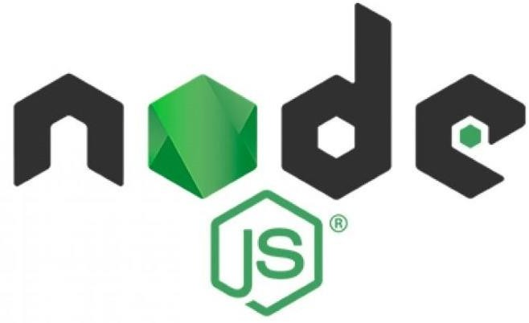

# CHAPTER 3 PROJECT IMPLEMENTATION

## CODES FOR PROJECT IMPLEMENTATION:

**HTML CODE FOR MAIN PAGE:**

<!DOCTYPE html>

<html lang="en">

<head>

<meta charset="UTF-8">

<meta name="viewport" content="width=device-width, initial-scale=1.0">

<title>SSBLog</title>

</head>

<style>

.main1{

font-size: larger;

font-family: sans-serif; align-items:center; gap: 0;

}

header{

align-items: center; justify-content: center; font-size: 150px; padding-left: 600px;

background-color: rgb(234, 240, 233) ;

}

.set{

align-items: center;

justify-content: center; padding-left: 650px;

}

.main2{

gap: 10px;

}

</style>

<body>

<header>SSBlog</header>

<div class="set" style="height: 100px;">

<h1 style="display: flex; align-items: center; font-weight: bolder;">ARTICLE</h1>

</div>

<div class="main1">

<h1 style="height: 10px; ;">CORRUPTION AT CRICKET</h2>

<p style="padding-top: 10px; font-family: sans-serif;">CSK AND RR WERE BANNED DUE TO MATCH FIXING

Cricket has a seedy underbelly that is often tainted by corruption

Corruptors will operate across all formats and levels of the game, including Women’s cricket Reporting from recent events has provided further insight into cricket corruption; including the

networks and corruptors involved, and the types of fixes and payments being offered

Ensure any offers for sponsorship or to play in leagues are done through the appropriate channels In a recent example an Associate Member answered a call from an unknown number

A frequent tactic to trap you is to get all expenses paid trips to somewhere like Dubai to discuss the offer</p>

<img src="./DM23IPL_5834.jpg" alt="" style="display: flex; justify-content: center; align-items: center;padding-left: 175px;">

</div>

<div class="main2" style="padding-top: 100px;">

<h2 style="height: 10px;font-size: 50px;">ENVIRONMENTAL DEVELOPMENT AND SUSTAINABILITY</h2>

<p style="font-size: larger; font-family: sans-serif; padding-top: 10px;">Economic growth, social inclusion and environmental protection

End hunger, achieve food security and improved nutrition and promote sustainable agriculture

This series covers current and emerging issues in order to promote debate and broaden the understanding of environmental challenges as integral to equitable and sustained economic growth

Drawing on analysis and practical experience from across the World Bank and from client countries, the books in this series will be central to the implementation of the World Bank’s Environment Strategy, and relevant to the development community, policy makers, and academia

"Without nature, we have nothing"

The Sustainable Development Goals(SDGs)provide a holistic framework for governments, businesses, civil society organizations, and individuals to work together towards a more equitable, inclusive, and sustainable world</p>

<img src="./green-energy-sustainable-industry-environmental-social-and-corporate-governance- concept-free-photo.jpg" alt="">

</div>

<div class="main3">

<h3 style="height: 10px; font-size: 50px;">GENDER INQUALITY IN INDIA</h2>

<p style="font-size: larger; font-family: sans-serif;">Gender inequality in India refers to health, education, economic and political

Various international gender inequality indices rank India differently on each of these factors, as well as on a composite basis, and these indices are controversial

In the context of India gender inequality is deeply rooted in societal norms, affecting opportunities, and while it impacts the lives of both the genders, statistically it is the girls that are the most disadvantaged

The girl child tends to face extensive limitations in mobility, decision-making and access to education and health services

Gender inequality in India is a multifaceted issue that primarily concerns women, but also affects

men

When India's population is examined as a whole, women are at a disadvantage in several

important ways</p>

<img src="./gender-inequality-scaled-removebg-preview.webp" alt="" style="padding-left: 500px;">

</div>

<div class="main4">

<h4 style="height: 10px; font-size: 50px;">VIOLENCE AGAINST WOMEN</h2>

<p style="font-size: larger; font-family: sans-serif;">Estimates published by WHO indicate that globally about 1 in 3 (30%) of women worldwide have been subjected to either physical

sexual intimate partner violence or non-partner sexual violence in their lifetime

Violence against women is a major public health problem and a violation of human rights

For women in many parts of the world, violence is a leading cause of injury and disability, as well as a risk factor for other physical, mental, sexual and reproductive health problems

Gender-based violence takes many forms: physical, sexual, emotional, and psychological

Examples include female genital mutilation, killing in the name of so-called ‘honor’, murder, forced and early marriage, and sex trafficking

Two of the most prevalent types of violence that women experience are intimate partner violence (IPV) and non-partner sexual violence (NPSV)

Almost one in three women across the world have experienced one or both of these forms of violence at least once in their lifetime</p>

<img src="./Stop-Violence-Against-Women-2.jpg" alt="" style="padding-left: 500px;">

</div>

<div class="main5">

<h5 style="height: 10px; font-size: 50px;">RAPID URBANIZATION</h2>

<p style="font-size: larger; font-family: sans-serif;">it is the rapid migration of people from rural to urban areas,and the resulting growth of cities

India’s urbanization is pivotal for its development, with a projection of 600 million urban dwellers by 2036

Significant investment in infrastructure, private financing, and public services is essential Priorities include enhancing transportation, increasing women’s workforce participation, and

addressing water security

The World Bank supports India’s vision to create livable, inclusive cities, crucial for becoming a developed nation by 2047

building the necessary infrastructure will be key for creating livable, climate-resilient, and inclusive cities that drive the economy forward

Since nearly 70 % of the urban infrastructure needed by 2047 is yet to be built, sizeable investments will be required</p>

<img src="./32qnegutfdp4r3bovfkcmjja2x6jc3sachvcdoaizecfr3dnitcq_3_0.png" alt="" style="padding-left: 350px;">

</div>

</body>

</html>

## OUTPUT:

The Output that we get in the project implementation is the figures ,codes and the HTML

,CSS and relevant Front-end and the Back-end that should be obtain from Visual Studio code.

## SSBlog

**ARTICLE**

**CORRUPTION AT CRICKET**

CSK AND RR WERE BANNED DUE TO MATCH FIXING Cricket has a seedy underbelly that is often tainted by corruption Corruptors will operate across all formats and levels of the game, including Women’s cricket Reporting from recent events has provided further insight into cricket corruption; including the networks and corruptors involved, and the types of fixes and payments being offered Ensure any offers for sponsorship or to play in leagues are done through the appropriate channels In a recent example an Associate Member answered a call from an unknown number A frequent tactic to trap you is to get all expenses paid trips to somewhere like Dubai to discuss the offer

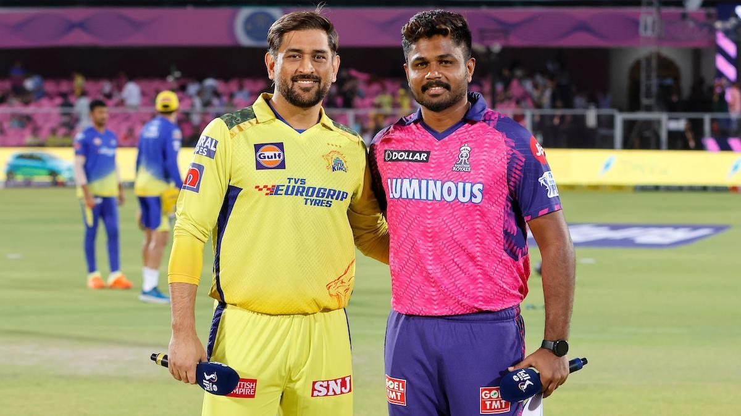

**ENVIRONMENTAL DEVELOPMENT AND SUSTAINABILITY**

Economic growth, social inclusion and environmental protection End hunger, achieve food security and improved nutrition and promote sustainable agriculture This series covers current and emerging issues in order to promote debate and broaden the understanding of environmental challenges as integral to equitable and sustained economic growth Drawing on analysis and practical experience from across the World Bank and from client countries, the books in this series will be central to the implementation of the World Bank’s Environment Strategy, and relevant to the development community, policy makers, and academia "Without nature, we have nothing" The Sustainable Development Goals(SDGs)provide a holistic framework for governments, businesses, civil society organizations, and individuals to work together towards a more equitable, inclusive, and sustainable world

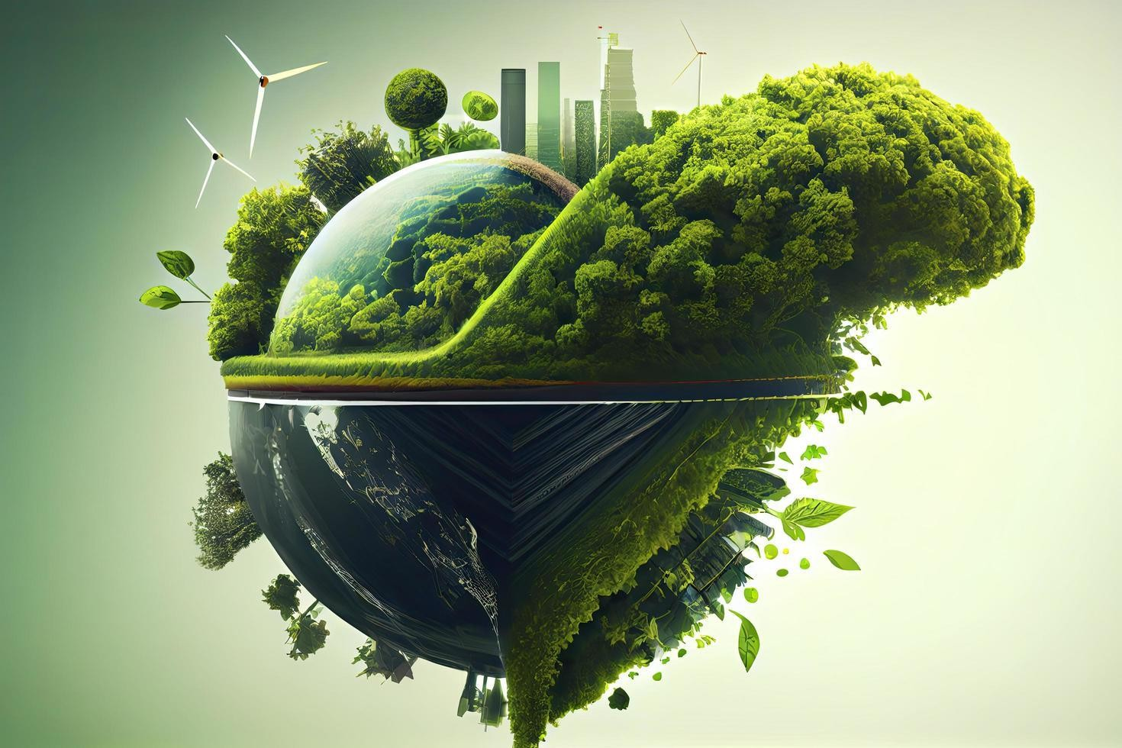

**GENDER INQUALITY IN INDIA**

Gender inequality in India refers to health, education, economic and political Various international gender inequality indices rank India differently on each of these factors, as well as on a composite basis, and these indices are controversial In the context of India gender inequality is deeply rooted in societal norms, affecting opportunities, and while it impacts the lives of both the genders, statistically it is the girls that are the most disadvantaged The girl child tends to face extensive limitations in mobility, decision-making and access to education and health services Gender inequality in India is a multifaceted issue that primarily concerns women, but also affects men When India's population is examined as a whole, women are at a disadvantage in several important ways

**VIOLENCE AGAINST WOMEN**

Estimates published by WHO indicate that globally about 1 in 3 (30%) of women worldwide have been subjected to either physical sexual intimate partner violence or non-partner sexual violence in their lifetime Violence against women is a major public health problem and a violation of human rights For women in many parts of the world, violence is a leading cause of injury and disability, as well as a risk factor for other physical, mental, sexual and reproductive health problems Gender-based violence takes many forms: physical, sexual, emotional, and psychological Examples include female genital mutilation, killing in the name of so-called ‘honor’, murder, forced and early marriage, and sex trafficking Two of the most prevalent types of violence that women experience are intimate partner violence (IPV) and non-partner sexual violence (NPSV) Almost one in three women across the world have experienced one or both of these forms of violence at least once in their lifetime



**RAPID URBANIZATION**

it is the rapid migration of people from rural to urban areas,and the resulting growth of cities India’s urbanization is pivotal for its development, with a projection of 600 million urban dwellers by 2036 Significant investment in infrastructure, private financing, and public services is essential Priorities include enhancing transportation, increasing women’s workforce participation, and addressing water security The World Bank supports India’s vision to create livable, inclusive cities, crucial for becoming a developed nation by 2047 building the necessary infrastructure will be key for creating livable, climate-resilient, and inclusive cities that drive the economy forward Since nearly 70 % of the urban infrastructure needed by 2047 is yet to be built, sizeable investments will be required

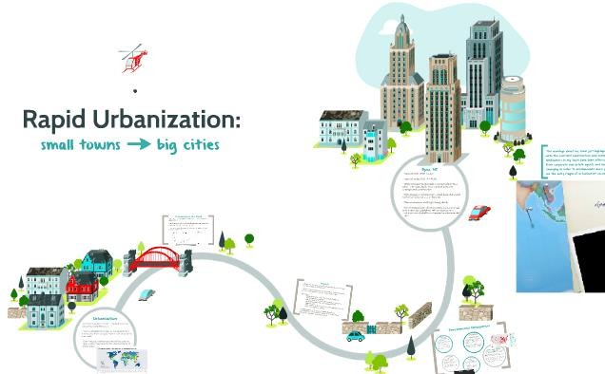

# CHAPTER 4 CONCLUSION

## CONCLUSION:

* Creating a RESTful API for a blogging website using Node.js, Express, and MongoDB involves setting up a Node project with necessary dependencies, connecting to MongoDB for data storage, defining a Mongoose schema for blogs, and implementing CRUD operations. This approach allows for efficient management of blog posts through endpoints for creating, reading, updating, and deleting content, ensuring a scalable and robust backend solution for a blogging application.
* Learn everything from Front-End to Back-End Development with hands-on Projects and real-world examples. This course enables you to build scalable, efficient, dynamic web applications that stand out. Ready to become an expert in Full-Stack? Enroll Now and Start Creating the Future!